**Vel Tech Rangarajan Dr. Sagunthala R&D Institute of Science and Technology**

 **(Deemed to be University Estd. u/s 3 of UGC Act, 1956)**

**School of Computing**

**B.Tech. – Computer Science and Engineering**

**VTR UGE2021- (CBCS)**

Academic Year: 2025–2026

SUMMER SEMESTER - SS2526

Course Code : 10211CS207

Course Name : Database Management Systems

Slot No : S6L15

DBMS TASK - 1 REPORT

Title: Conceptual Design through FTR

Submitted by:

|  |  |  |
| --- | --- | --- |
| **VTUNO** | **REGISTER NUMBER** | **STUDENT NAME** |
| VTU29420 | 24UECS1386 | S.SIDDU |

**TNCA Management System**

**Abstract:** The Tamil Nadu Cricket Association (TNCA), is the governing body for cricket in the Indian state of Tamil Nadu. Affiliated with the Board of Control for Cricket in India (BCCI), the TNCA plays a vital role in promoting, organizing, and overseeing cricket activities within the state. The primary objective of the TNCA is to develop and nurture cricket talent in Tamil Nadu, providing aspiring cricketers with opportunities to showcase their skills at various levels. The association conducts a wide range of domestic cricket tournaments, including first-class matches, one-day competitions, and T20 tournaments, which serve as a platform for players to compete and demonstrate their capabilities. One of the key responsibilities of the TNCA is to manage cricket infrastructure, including maintaining cricket stadiums, grounds, and training facilities to meet international standards. The association strives to create a conducive environment for cricket development, facilitating the growth of the sport in the region. Overall, the Tamil Nadu Cricket Council plays a pivotal role in fostering the spirit of cricket in the state, nurturing talent, and maintaining the rich cricketing heritage of Tamil Nadu. Through its dedicated efforts, the association continues to shape the future of cricket in the region and contribute significantly to the sport on a national and international level. Tamil Nadu Cricket Council Management System is a browser based solution that is designed to store, process, retrieve and analyse information concerned with the administrative, conducting tournaments and match aspects of providing services within a TNCA management system. The ‘TNCA Management System’ allows us to keep track of matches of tournament and also keeps track of players when requested.

**TASK 1: Conceptual Design through FTR**

**Aim:**

Using basic database design methodology and ER modeler, design Entity Relationship Diagram by satisfying the following sub tasks:

* 1. **a** Identifying the entities.

1. **b** Identifying the attributes.

**1. c** Identification of relationships, cardinality, type of relationship.

**1. d** Reframing the relations with keys and constraint.

1. **e** Using create, develop ER/ER diagram

**1.a Identifying the entities**

1.a.1 CricketBoard

1.a.2 Team

1.a.3 Player

1.a.4 Match

1.a.5 Ground

1.a.6 Umpire

**1.b Identifyingtheattributes**

1.b.1 CricketBoard(BoardID, Name, Address, Contact_No)

1.b.2 Team(TeamID, Name, Coach, Captain)

1.b.3 Player(PlayerID, FName, LName, Age, DateofBirth, PlayingRole, email, contact_no)

1.b.4 Match( MatchID, Date, Time, Result)

1.b.5 Ground(GroundID, Name, Location, Capacity)

# 1.b.6 Umpire(UmpireID, FName, LName, Age, DateofBirth, Country, email, contact_no)

# **1.c Identification of relationships, cardinality, type of relationship.**

1.c.1 **Board-Team Relationship:** The Board will have a **one-to-many** relationship with Teams since the board can have multiple teams affiliated with it, but a team can only be associated with one board.

1.c.2 **Team-Player Relationship:** Teams and Players will have a **many-to-many** relationship since a team can have multiple players, and a player can be a part of multiple teams over time.

1.c,3. **Match-Team Relationship:** Matches will have a **many-to-many** relationship with Teams, as a match involves two teams, and a team can participate in multiple matches.

1.c.4. **Match-Ground Relationship:** Matches will have a **one-to-one** relationship with Grounds, as each match takes place in one specific ground.

**1.d Reframing the relations with keys and constraint**

**1.d.1 Create Table CricketBoard:**

**SQL>create table CricketBoard(**BoardID varchar(10) PRIMARY KEY, Name varchar(30), Address varchar(50), Contact_No number);

Table Created

SQL>DESC CricketBoard

|  |  |  |
| --- | --- | --- |
| Column | NULL | TYPE |
| BoardID | NOT NULL | VARCHAR(10) |
| Name | - | VARCHAR(30) |
| Address | - | VARCHAR(50) |
| Contact_No | - | NUMBER |

**1.d.2 Create Table Team:**

**SQL> create table Team(TeamID varchar(10) PRIMARY KEY, BoardID varchar(10), Name varchar(30), Coach varchar(30), Captain varchar(30), FOREIGN KEY(BoardID) REFERENCES CricketBoard(BoardID));**

**Table created.**

**SQL> DESC TEAM**

Name Null? Type

----------------------------------------- -------- ----------------------------

TEAMID NOT NULL VARCHAR2(10)

BOARDID NOT NULL VARCHAR2(10)

NAME - VARCHAR2(30)

COACH - VARCHAR2(30)

CAPTAIN - VARCHAR2(30)

**1.d.3 Create Table Player:**

SQL> CREATE table Player(PlayerID varchar(6) PRIMARY KEY, TeamID varchar(10), FName varchar(30), LName varchar(30), Age number(5,2), DateofBirth date, PlayingRole varchar(25), email varchar(40), contact_no number, FOREIGN KEY(TeamID) REFERENCES Team(TeamID));

Table created.

SQL> DESC PLAYER

Name Null? Type

----------------------------------------- -------- ----------------------------

PLAYERID NOT NULL VARCHAR2(6)

TEAMID NOT NULL VARCHAR2(10)

FNAME VARCHAR2(30)

LNAME VARCHAR2(30)

AGE NUMBER(5,2)

DATEOFBIRTH DATE

PLAYINGROLE VARCHAR2(25)

EMAIL VARCHAR2(40)

CONTACT_NO NUMBER

**1.d.4 Create Table Match:**

SQL> create table Match( MatchID varchar(10), TeamID1 varchar(10), TeamID2 varchar(10), Match_Date date, Time1 number, Result varchar(20), PRIMARY KEY(MatchID), FOREIGN KEY(TeamID1) REFERENCES team(TeamID), FOREIGN KEY(TeamID2) REFERENCES team(TeamID));

Table created.

SQL> DESC Match

Name Null? Type

----------------------------------------- -------- ----------------------------

MATCHID NOT NULL VARCHAR2(10)

TEAMID1 NOT NULL VARCHAR2(10)

TEAMID2 NOT NULL VARCHAR2(10)

PLAYERID NOT NULL VARCHAR2(6)

MATCH_DATE DATE

TIME1 NUMBER

RESULT VARCHAR2(20)

**1.d.5 Create Table Ground:**

SQL> create table Ground(GroundID varchar(10) PRIMARY KEY, MatchID Varchar(10), Name varchar(30), Location varchar(30), Capacity number, FOREIGN KEY(MatchID) REFERENCES Match(MatchID));

Table created.

SQL> DESC Ground

Name Null? Type

----------------------------------------- -------- ----------------------------

GROUNDID NOT NULL VARCHAR2(10)

MATCHID NOT NULL VARCHAR2(10)

NAME VARCHAR2(30)

LOCATION VARCHAR2(30)

CAPACITY NUMBER

**1.d.6 Create Table Umpire:**

**SQL>** Create Table Umpire(UmpireID varchar(10) PRIMARY KEY, FName varchar(30), LName varchar(30), Age number(5,2), DateofBirth date, Country varchar(30), email varchar(40), contact_no number);

SQL> DESC Umpire

Name Null? Type

----------------------------------------- -------- ----------------------------

UMPIREID NOT NULL VARCHAR2(10)

FNAME VARCHAR2(30)

LNAME VARCHAR2(30)

AGE NUMBER(5,2)

DATEOFBIRTH DATE

COUNTRY VARCHAR2(30)

EMAIL VARCHAR2(40)

CONTACT_NO NUMBER

**1.d.6 Create Table Umpire_Umpired:**

SQL> create table Umpire_Umpired(UmpireID varchar(10), MatchID Varchar(10), GroundID varchar(10), FOREIGN KEY(UmpireID) REFERENCES Umpire(UmpireID), FOREIGN KEY(MatchID) REFERENCES Match(MatchID), FOREIGN KEY(GroundID) REFERENCES Ground(GroundID));

Table created.

SQL> DESC Umpire

Name Null? Type

----------------------------------------- -------- ----------------------------

UMPIREID NOT NULL VARCHAR2(10)

GROUNDID NOT NULL VARCHAR2(10)

MATCHID NOT NULL VARCHAR2(10)

**1.e. Using creately, develop ER/EER diagram**

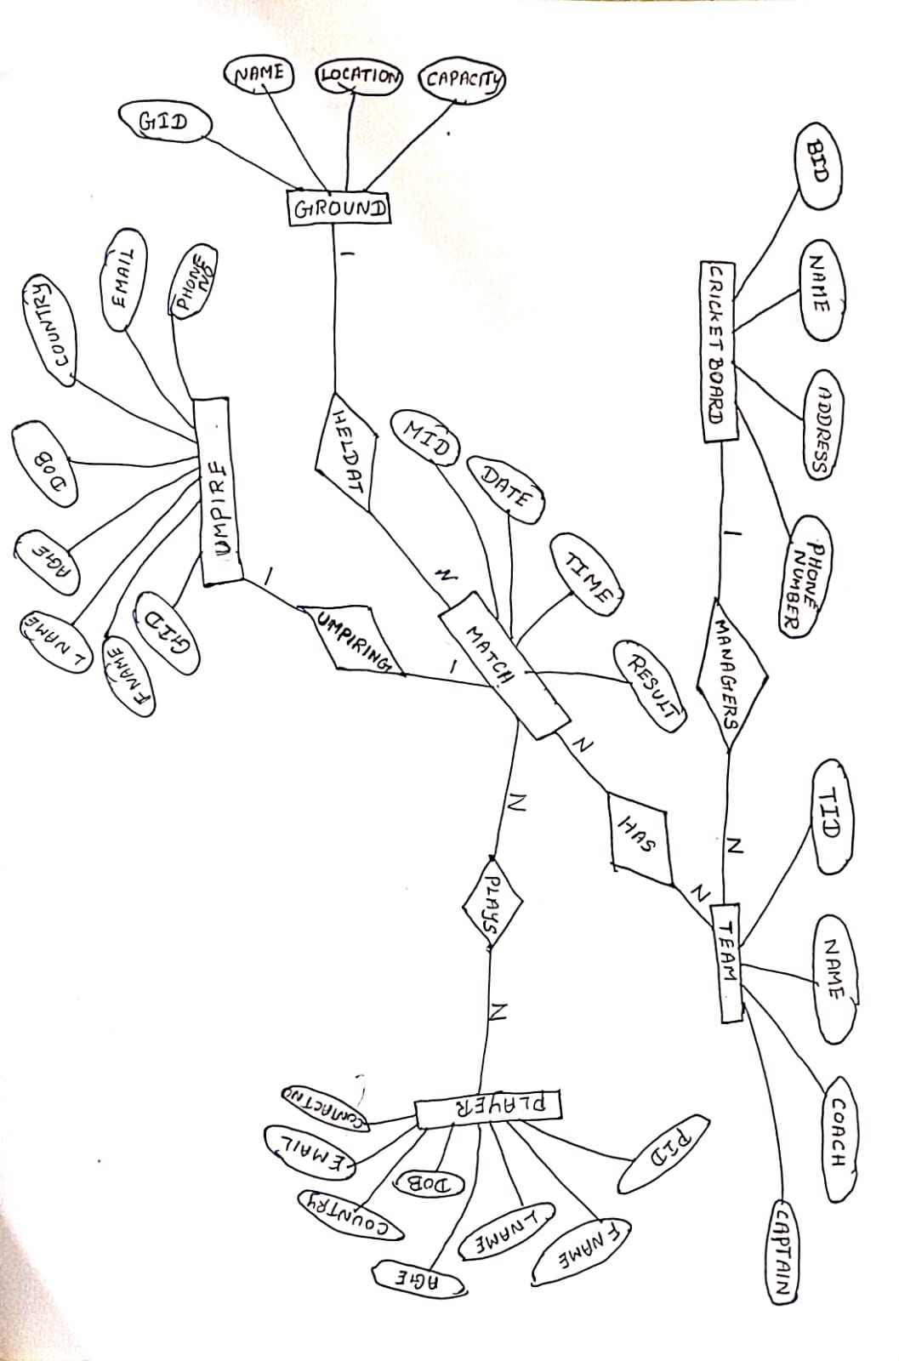

**Result:**

Thus the database design methodology and ER Model design diagram has been completed successfully.